**Project title: Online Shopping Store System**

**Project specification**

* **General description:** We used C programming language. Our project is about online shopping store system so we have 2 main characters; Owner of the store and the customer. We made two separate sections. First section is for the owner and he can add products to the inventory, delete products, and update products. For the customer he can buy products.
* **Basic function in implementation level:** IsEmpty, ProdcutDisplay, Buy, CheckProduct, AddProduct, DeleteProduct, and UpdateProduct.
* **Basic function in user level:** Menu

**Project design and implementation**

**Imported libraries:** <stdio.h>, <stdlib.h> and <stddef.h> .

**Flow chart:** 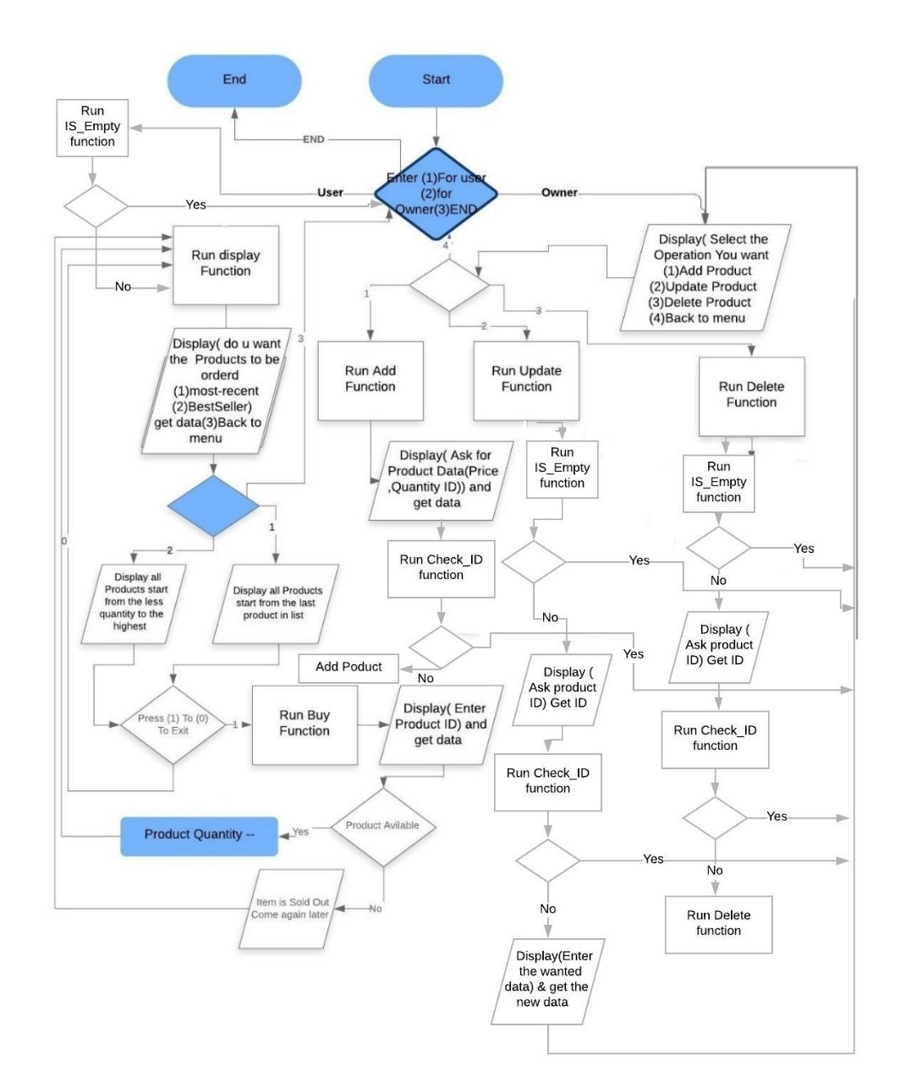

**Designed algorithm**

* **General algorithm**: Well, we used the linked-list data structure because it’s appropriate for our project. We made 3 structs which are Product and node. Struct product for saving the data of product; ID, name, price, and quantity. Struct node has the “next” of the linked-list.
* **Function menu:** The function will make the user choose between two choices which are 1- Owner and 2- User want to buy. If he is the owner, the function will give him more choices whether he wants to add product, delete product, update product, and the last choice will triggered if choose wrong choice. If he is a user, the function will display the products for him and ask him if he wants to buy on or more product, of course, if there are products and the function will check this before the user can buy anything.
* **Function IsEmpty:** This function indicates whether there are products or no. It takes “*L” as a parameter. It will return zero if there are no products and one if there are products.
* **Function ProductDisplay:** This function is to display products with two options; Display by best seller or display by recently added. It won’t return anything and it will take “*L” as a parameter. For the recently added, we will just return the data because we add the products in the first the linked list, so it’s first in last out, that’s exactly we want to do. For the best seller, it displays by the lowest quantity by storing all of the quantities of the products in an array then we sort it so we can get the product that has the lowest quantity; means, that the first index of the array has the lowest quantity therefore it’s the best seller.
* **Function CheckProduct:** This function to check if we have this product or no and we will use it in the other functions. The function will take “L” and the ID of the product that we are asking about as parameters and it will return integer. If it found the ID we are looking for it, the function will return 1. If the function didn’t find the ID of the product, it will return zero.
* **Function Buy:** Thisfunction made for the customer so he can buy products. Basically, it will check if the product exists or no. If the product exists, the product will be available for the user to buy it and the function will decrease the quantity of this product by one. If the product doesn’t exist, the function will display for the user that this product isn’t available or he entered wrong ID.
* **Function AddProduct**: This function is for the owner so he can add the products he wants. First of all, it will check if the product is already existed or no by using the function “checkproduct”. If the product exists, the function will display for the owner that he already added this product. If it doesn’t exist, the function will ask the owner about the data of this product which are name, price, and Product Quantity. After the function takes the data from the owner, it will reserve a part from the memory to this new product by using some built-in functions; functions are malloc and sizeof.
* **Function update product:** This function will be for the owner to update whatever product he wants. The function will ask the owner about the ID of this product and check if the product is already existed or no by using the function “checkproduct”. If the product doesn’t exist, the function will display a message for the user that he entered wrong ID. If the product exists, the function will ask the user on which part he wants to update by using “swtich method”
* **DeleteProduct:** It will check if there is an product to delete or no if there is no product, the function will display a message for the user saying there is no product to delete. If there is a product, the function will ask the user about the product’s ID that he want to delete, of course, it will check if the ID exists or no. Once we get the ID of the product we will make two variables from type node, we will use them to save the product that we want to delete in it and make the previous node point on the node after the product that we want to delete. After all of that we will “Free” function to erase the node holding the product we want to delete it.